Note: Include this page only when adding / amending / deleting a document. If using this document as a record, this Revision History page can be omitted.

REVISION HISTORY

Revision no | Date | Description of Changes | Reason for Revision | Revised by | Approved by
2 | 08 May 13 | Add revision history page  Added Notes | - Recommendation from Stage 2 audit | RDPlacido  WRRobles
3 | 02 Jun 14 | Added Notes  Revised Evaluation Procedure | Improvement | WRRobles
4 | Apr. 8, 2016 | Added disclaimer when printing the document | For document control | RCGanal | WRRobles
5 | 16 Aug 2016 | Update Notes and References | Improvement | MCDy
TM-BR-MG- 11 Rev02, 10302015

- Objective

To ensure that critical suppliers are selected, evaluated and re-evaluated based on set criteria so as to meet the company’s expectations.

- Scope

This procedure defines the actions and responsibilities of the Requestor, AP Accountant, Unit Heads, and Execom in Supplier Control. This covers activities from receipt of request to purchase, selection of suppliers and monitoring of supplier’s performance.

- Definition of Terms

- Procedure Details
RESPONSIBLE | ACTIVITY | INTERFACE
AP Accountant  AP Accountant/Admin Assistant  AP Accountant  Execom  AP Accountant | SUPPLIER ACCREDITATION PROCEDURE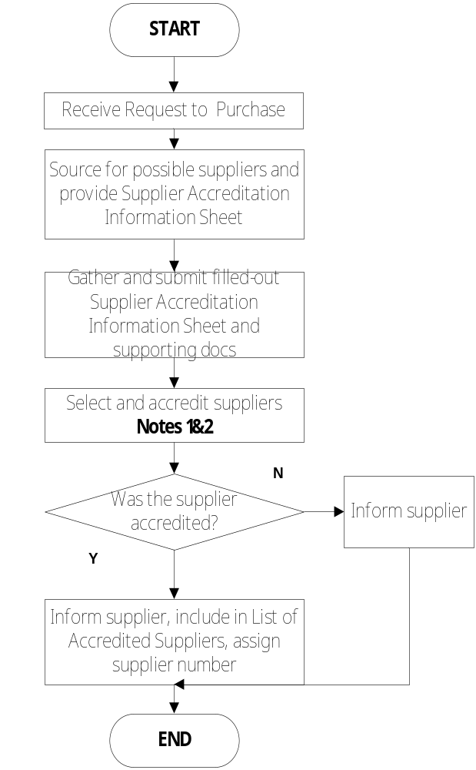 | Requestor  Possible Suppliers  Execom  Supplier Evaluation Sheet  Rejected Supplier  List of Accredited Suppliers

SUPPLIER PERFORMANCE EVALUATION PROCEDURE
RESPONSIBLE | ACTIVITY | INTERFACE
AP Accountant | 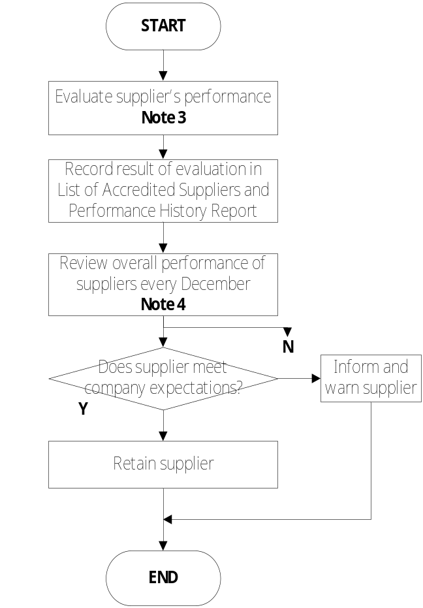 | End Users / Unit Heads/Technical Staff  Performance Evaluation of Supplier  List of Accredited Suppliers & Performance History Report  Finance Head

Notes :
- Selection of potential suppliers
A potential supplier shall undergo selection process of the company. Selection shall be based on the following criteria:
  - Ability to supply 20%
  - Competitive price 20%
  - Responsiveness 15%
  - Submission of documents 15%
  - Reputation 15%
  - Capability to deliver 10%
  - Location 5%

To become accredited, a supplier must get at least 75% score.

The following types of suppliers are exempted from attaining the minimum passing score:
- Sole source supplier (e.g. Oracle Corp)
- Highly preferred/recommended supplier

The Supplier Selection Sheet (FO-FI-FI-24) shall be used when evaluating a prospective supplier.

- The following purchases are not required to undergo accreditation process:
  - Over the counter purchases (e.g. grocery, drugstore, fast food)
  - One-time purchase not exceeding twenty five thousand pesos (P25,000.00)
  - Petty cash fund and training fund purchases
  - Reimbursements

- Performance Evaluation of Current Suppliers
  - Criteria
- Timeliness of delivery
- Quality of products delivered
- Quality of after sales service
- Conformance to specs

  - Timing of evaluation
- Within 3 months from date of delivery for Hardware and software purchases
- At least once a year for other purchases

- Re-evaluation of Current Suppliers
An overall review of performance of the suppliers shall be done every December to determine who among the suppliers are to be maintained. Basis of evaluation is the List of Accredited Suppliers and Performance History Report. Results of performance evaluation and recommendations are:
  - Meets company expectations
  - Meets company expectation but with minor complaints
  - With major complaint, warn supplier
  - Do not consider in future requirements

- References

- Quality Records

- Supplier Accreditation Information Sheet
- List of Accredited Suppliers & Performance History Report
- Supplier Selection Sheet
- Request to Purchase
- Supplier Performance Evaluation

